**Experiment 9**

**MOSFET Voltage Divider Bias**

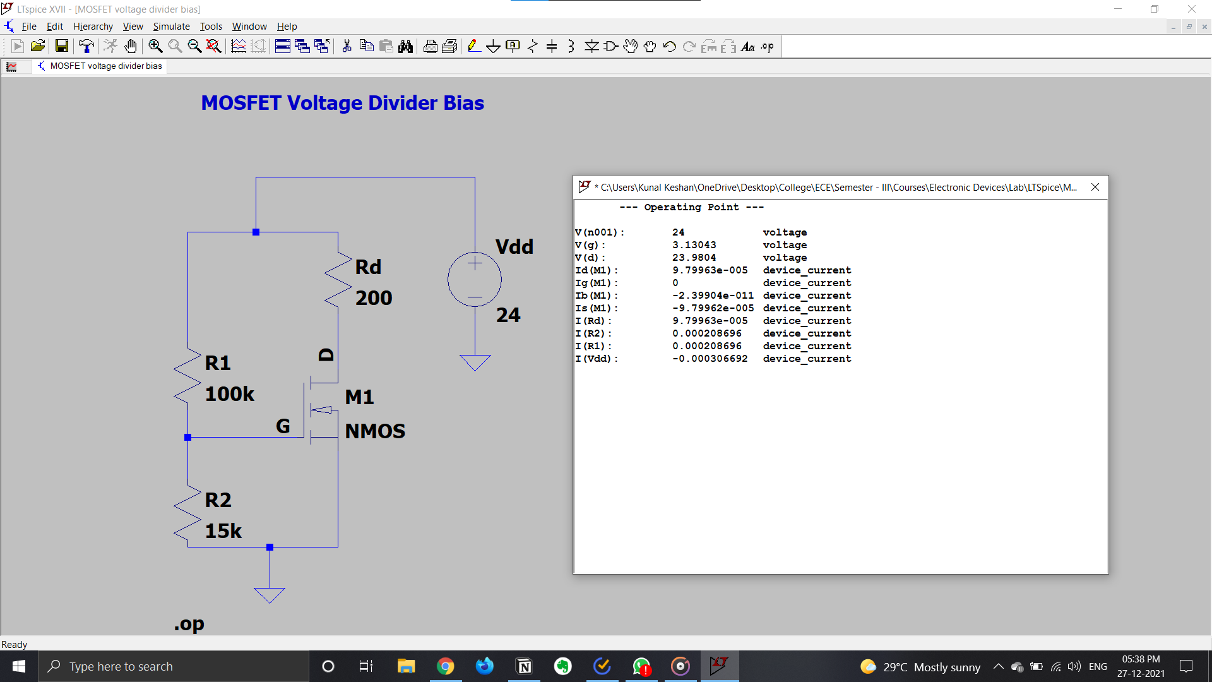

**MOSFET Drain Feedback Bias**

